CRM nErgy Software Development Highlights

INCLUDE


Secured Communications eBox
In the CRM nErgy software – include a secured chat inbox for communication between
CRM nErgy’s Super Executive Admin [ SEA ] and Kiaan Tech Team [ KTT ]. The SEA is the only person allowed to communicate directly with the [ KTT ] in this environment.

Internal Search Engine Bar:

Search docs, tasks, files and others with AI

Fully Translatable into Spanish CRM ERP

[ CRM ERP software ] and [ CRM ERP website ]

Instant Website Translation
website pages and funnels can be viewed in English or Spanish with just one click—no extra plugins required. [ I seen this on a competitor’s site ] I work with Spanish speaking clients this is very necessary.
I spend a lot of time in California.

Tutorial Training Videos

Comprehensive tutorial videos are essential for understanding and utilizing CRM features effectively. These resources help users grasp terminology and learn how to navigate various functionalities within CRM systems.

FAQs DATA SEARCH BAR ENGINE
8/11/2026 Aug 11, 6:07 AM
Yes, we can make this much smarter than a normal FAQ system by using an AI-powered centralized Knowledge Base with RAG. The main benefits would be: - All FAQs and product knowledge managed from one central place - The same knowledge can automatically serve 100+ website pages - Visitors can ask questions naturally instead of searching manually - AI answers based on your actual CRM/ERP information, reducing incorrect answers - New questions and information can be added anytime without changing every page - We can identify questions customers are asking that aren't yet in the knowledge base - The same system can later power your website assistant, CRM assistant, ERP assistant, customer support, and AI agents - We can use open-source/free RAG technology for much of the system and connect an AI API only where needed, helping control ongoing costs. So instead of building just an FAQ section, we build one central AI knowledge system that grows with the entire platform.

Customizable Dashboards

[ Drag-and-Drop Interface ]

Easy to navigate CRM, a clean and streamlined user friendly interface that allows users to quickly access the features they need without getting lost in complex menus.

Customizable dashboards and smart bookmarks can enhance usability and efficiency.

How do customizable dashboards enhance CRM user experience?
Easy navigational CRM features Drag-and-Drop interface, which allows users to easily organize and manage contacts, tasks, and sales pipelines with minimal clicks. This intuitive design enhances user experience and productivity by simplifying common tasks.
Customizable dashboards enhance CRM user experience by allowing users to tailor the interface to their specific roles and responsibilities, presenting only the most relevant information. This targeted approach improves productivity and helps users focus on key performance indicators that matter most to their tasks.
Comparison of CRM Features
Feature | Description | Benefits
Drag-and-Drop Interface | Allows easy organization of tasks and contacts | User-friendly, efficient
Intuitive Dashboard | Customizable view of key metrics and tasks | Quick access to important info
Streamlined Contact Management | Easy addition and retrieval of contact information | Saves time, reduces frustration
Task Reminders | Automated notifications for follow-ups | Ensures timely actions
Pipeline Visibility | Visual representation of sales opportunities | Enhances tracking and management
These features collectively contribute to a more efficient and enjoyable user experience, making CRMs easier to adopt and use effectively.

EXAMPLE: 1
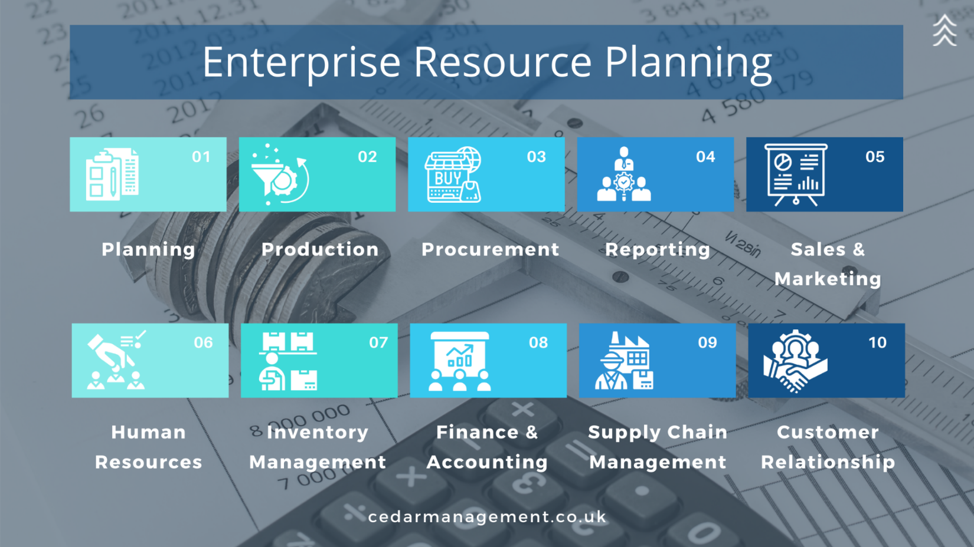

EXAMPLE: 2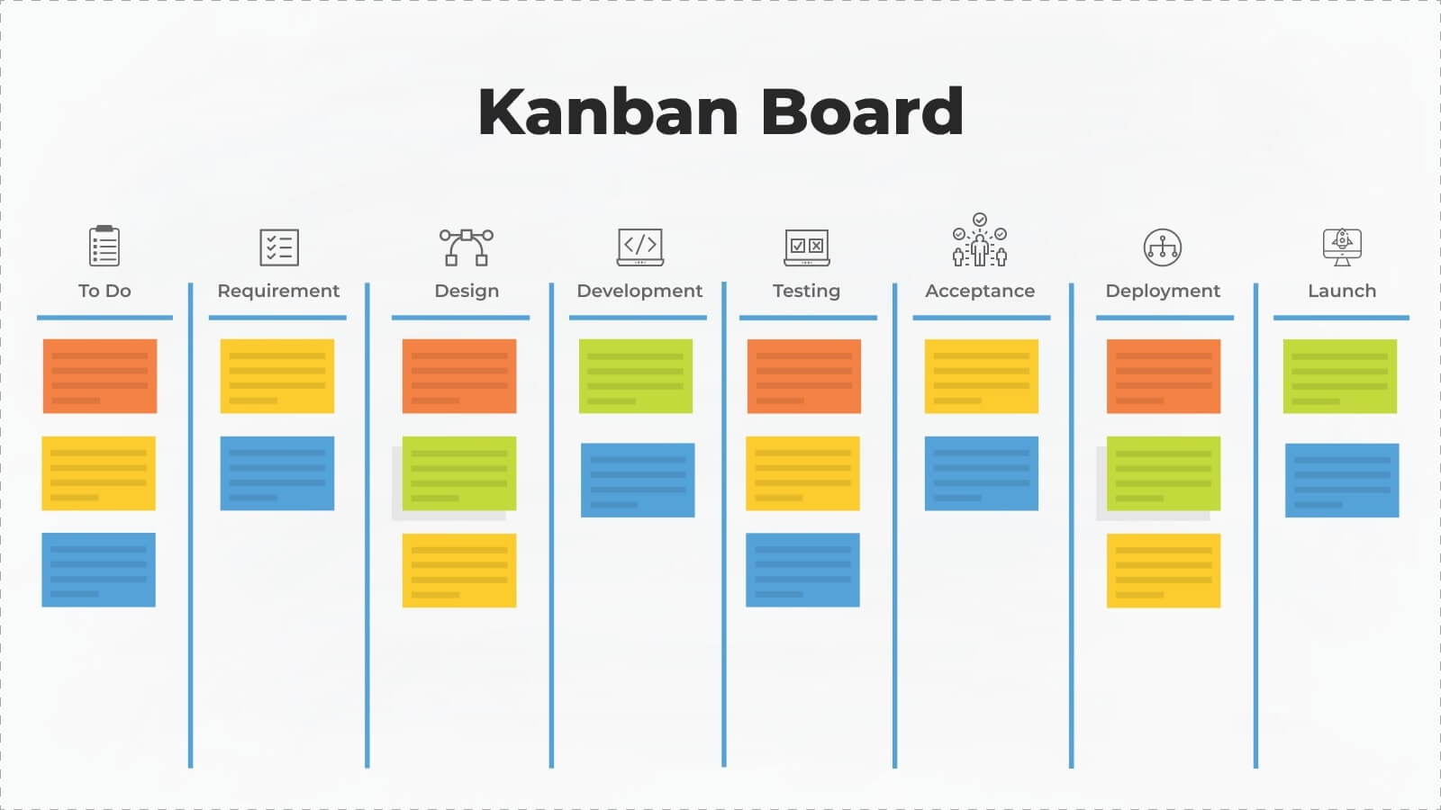
EXAMPLE: 3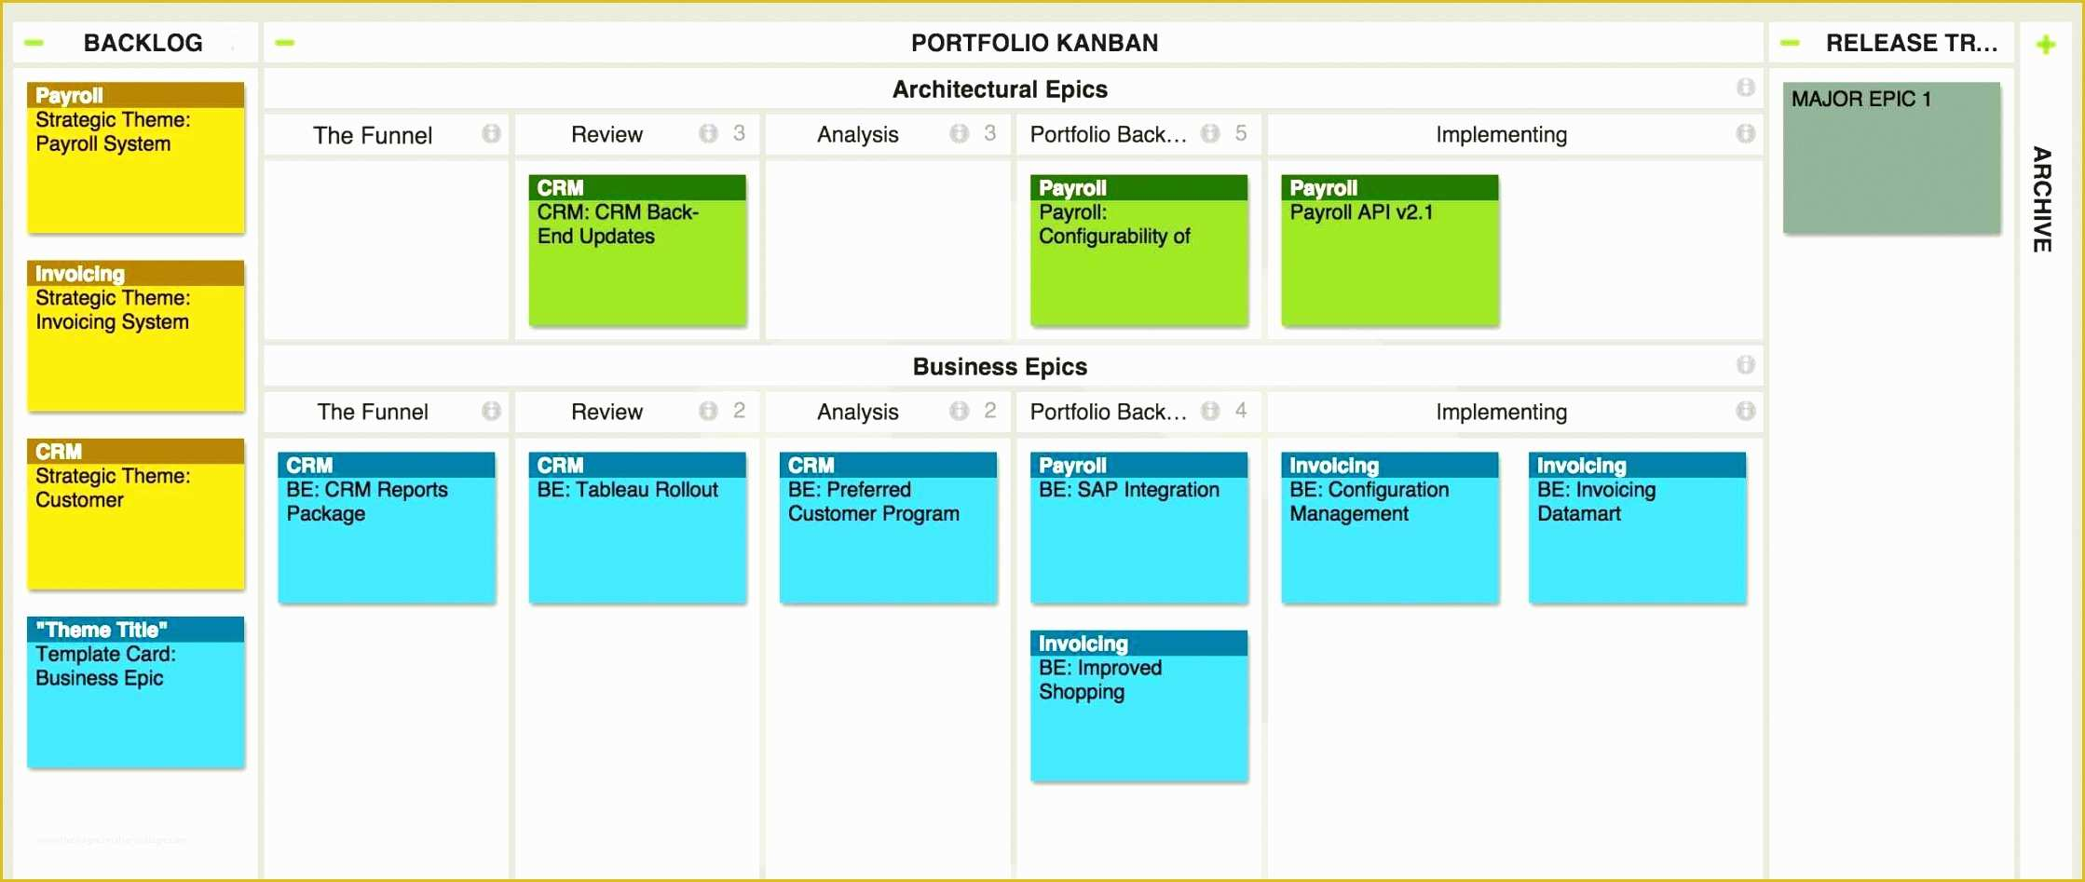
EXAMPLE: 4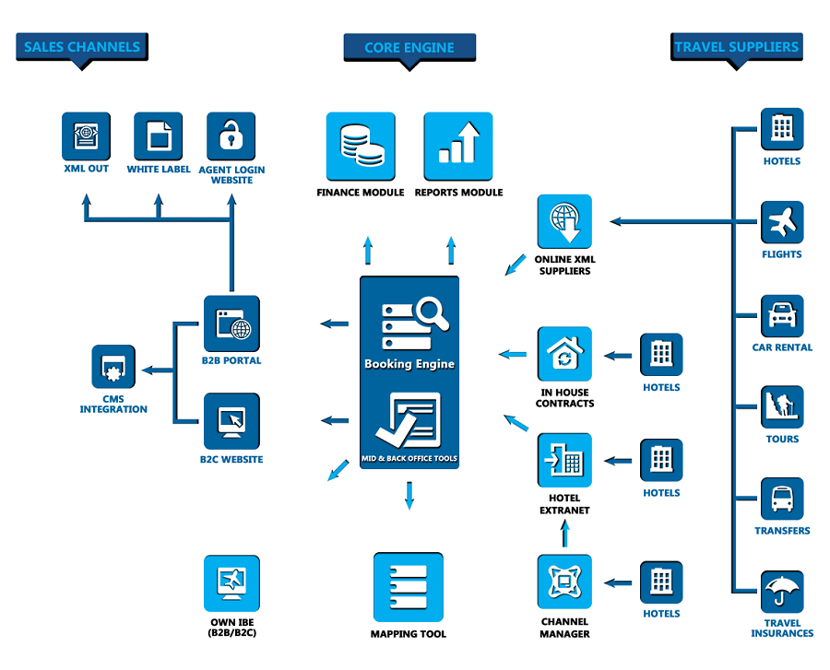
https://www.provab.com/apis-xmls/wp-content/uploads/2025/12/Amadeus-Software-1.png
EXAMPLE: Reports & Analytics
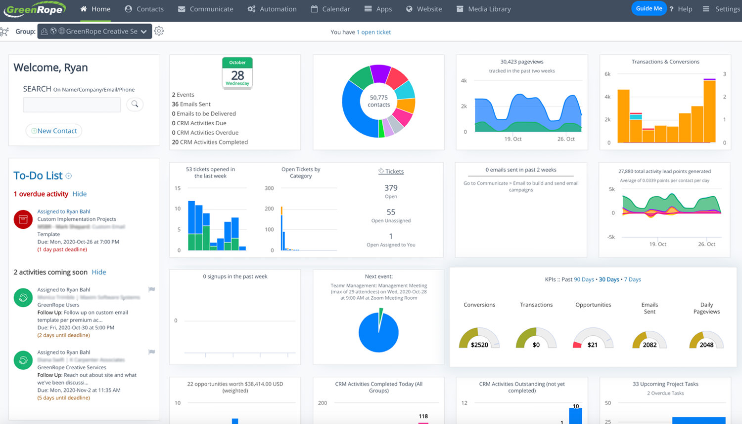
https://app.greenrope.com/users/myteam29042/Media1787.jpg

